TECHNICAL PROJECT REPORT

# Title of Invention / Project: Car Accident Detector

# Team Members / Inventors:

|  |  |  |  |  |  |
| --- | --- | --- | --- | --- | --- |
| **S. No.** | **Name** | **Department** | **Designation** | **Mobile** | **E-Mail** |
| 1. | Naman Parashar | CC | Student | 7347597903 | [namandev399@gmail.com](mailto:namandev399@gmail.com) |
| 2. | Subham Bhandari | CC | Student | 8077579568 | [08subhambhandari08@gmail.com](mailto:08subhambhandari08@gmail.com) |
| 3. | Kritick Sharma | CC | Student | 9149656495 | kriticksharma1445@gmail.com |
| 4. | Vedant Purohit | CC | Student | 9993736515 | [vedantpurohit1122@gmil.com](mailto:vedantpurohit1122@gmil.com) |
| 5. | Khushal Thakur | ECE | Mentor | 9646030764 | [khushal.thakur@cumail.in](mailto:khushal.thakur@cumail.in) |
| 6. | Anshul Sharma | ECE | Mentor | 9478697475 | [anshulsharma.ece@cumail.in](mailto:anshulsharma.ece@cumail.in) |
| 7. | Kiran Jot Singh | ECE | Mentor | 9463909689 | [kiranjotsingh.ece@cumal.in](mailto:kiranjotsingh.ece@cumal.in) |
| 8. | Divneet Singh Kapoor | ECE | Mentor | 9878422653 | [divneet.ece@cumail.in](mailto:divneet.ece@cumail.in) |

Section – 1 (IPR Related)

# Brief Abstract (500 words)

**Abstract:**

The project is designed to develop distance measurement system using ultrasonic waves and interfaced with arduino. We know that human audible range is 20hz to 20khz. We can utilize these frequency range waves through ultrasonic sensor HC-SR04.The advantages of this sensor when interfaced with arduino which is a control and sensing system, a proper distance measurement can be made with new techniques. As large amounts are spent for hundreds of inflexible circuit boards, the arduino will allow business to bring many more unique devices. This distance measurement system can be widely used as range meters and as proximity detectors in industries. The hardware part of ultrasonic sensor is interfaced with arduino. This method of measurement is efficient way to measure small distances precisely. The distance of an obstacle from the sensor is measured through ultrasonic sensor. After knowing the speed of sound the distance can be calculated.

**I. INTRODUCTION**

Today’s the developing world shows various adventures in every field. In each field the small requirements are very essential to develop big calculations. By using different sources we can modify it as our requirements and implement in various field. In earlier days the measurements are generally occur through measuring devices. But now a day’s digitalization as is on height. Therefore we use a proper display unit for measurement of distance. We can use sources such as sound waves which are known as ultrasonic waves using ultrasonic sensors and convert this sound wave for the measurement of various units such as distance, speed. This technique of distance measurement using ultrasonic in air includes continuous pulse echo method, a burst of pulse is sent for transmission medium and is reflected by an object kept at specific distance. The time taken for the sound wave to propogate from transmitter to receiver is proportional to the distance of the object. In this distance measurement system we had ultrasonic sensor HC-SR04 interfaced with arduino UnoR3. Programming and hardware part of ultrasonic sensor interfacing with arduino UnoR3.

**ARDUINO UNO R3**

The Arduino Uno is a microcontroller board based on the ATmega328 (datasheet). It has 14 digital input/output pins (of which 6 can be used as PWM outputs), 6 analog inputs, a 16 MHz crystal oscillator, a USB connection, a power jack, an ICSP header, and a reset button. It contains everything needed to support the microcontroller; simply connect it to a computer with a USB cable or power it with a AC-to-DC adapter or battery to get started.

**ULTRASONIC SENSOR-SR04**

It emits an ultrasound at 40 000 Hz which travels through the air and if there is an object or obstacle on its path It will bounce back to the module. Considering the travel time and the speed of the sound you can calculate the distance.

# Existing state-of-the-art and Drawbacks in existing state-of-the-art

|  |  |  |
| --- | --- | --- |
| **S. No.** | **Existing state of art** | **Drawbacks in existing state of art** |
| 1 | Arduino, Piezo buzzer, wires, jumper wire, LED, arduino wire, ultrasonic sensor. | It can sense any object near it. |

# Novel/Additional modifications that you can propose to improve upon drawbacks

* LCD can also included to determine the distance.
* This project can be connected to the brakes of the car so that an accident can be avoided.

# Advantages

* It can also be used as car parking system.
* Reduces accident by 14%.

# Block Diagram

**Piezo buzzer and LED.**

**Arduino board**

**Ultrasonic Sensor**

Section – 2 (Real Project)

# Materials

Arduino board, Piezo buzzer, ultra sonic sensor, jumping wires, LED.

# Circuit Diagram

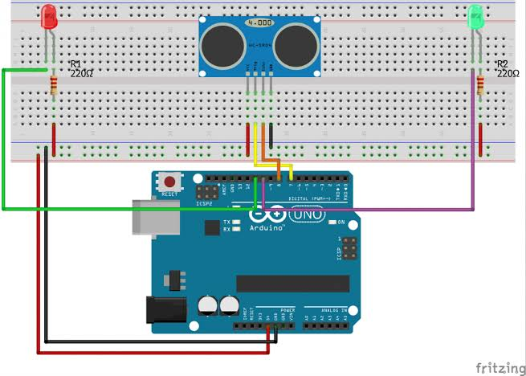

# Steps of Circuit Completion

1. Connect vcc of ultrasonic sensora to 5v of arduino
2. Connect trig pin of ultrasonic sensor to 9 of arduino
3. Connect echo to 10 of arduino
4. Connect gnd to gnd
5. Connect buzzer’s +ve to 11 and –ve to gnd
6. Connct led’s +ve to 13 and –ve to gnd

# Program Code